A Crash Course in Lesson Planning

Great lessons start with good planning and end with good classroom management. Whether you are just starting out and constantly asking yourself “What am I doing next period?” or looking to improve the flow and effectiveness of your current lessons, everyone benefits from taking a look at new ideas. What follows is a combination of information from the JET Linguistics and Pedagogy Course, the book Teach Like a Champion by Doug Lemov, the National Capital Language Resource Center’s “Essentials of Language Teaching” website, and five years of JET ALT experience at elementary, junior high and high schools, as well as English camps and visits to special-needs schools. We’ll start by discussing the basic structure of a lesson, then move on to create one, and finally some free (and probably worth every yen) advice.

THREE WAYS TO UNDERSTAND LESSON STRUCTURE

Students love structure. They like knowing what to do, how to succeed, what’s coming next – and as a teacher, you can use this to your advantage. There are many ways to structure lessons, and while most follow a similar pattern, it is helpful to see how different experts express it. First we’ll cover a conceptual way to look at lesson structure from Teach Like a Champion, then a concrete format from the JET Linguistics and Pedagogy Course, and finally a specialized reading/writing class structure from TEFL.

I – We – You from Teach Like a Champion

First I demonstrate, then we do together, then you do by yourself. This concept ensures that students aren’t sent off to do the work by themselves before they have mastered practicing it with the teacher, and lends itself well to a variety of subjects and grade levels. Not only does it cover the entire structure of a lesson, but it also applies to each concept taught during the lesson.

For the “I” portion of a lesson, you start by drawing the students into the lesson, perhaps with a story or explaining how useful the lesson information will be. You then give them the language tools they will need to accomplish your lesson’s goal – vocabulary, grammatical structures – often by breaking down the process into manageable steps. It is very important that you both properly model what the students are expected to learn and explain what they are learning, particularly within the greater context of your curriculum or even life. This is also not a place to forego student interaction – you can ask plenty of questions to keep the class engaged. Finally, the more practice you get as a teacher, the better you will be at anticipating student misunderstandings and questions during this phase of the lesson, helping make the introduction and presentation of material much smoother.

Moving on to the “We” potion of a lesson, you start bringing students into the process of language production. First you could model the dialogue with a student, and then change roles to have them ask you questions. During this phase it is very important to allow the students to think through the process, allowing them to do most of the cognitive legwork. Questions such as “What comes next?” and “How can this be more polite?” will help you gauge what the students still don’t understand, and positive reinforcement will encourage students to make mistakes and think of the answers on their own.

The “You” portion is typically the climax of the class or lesson section, when students go off to do the work in pairs or groups, and where they get the very important elements of repetition, independence, and multiple scenarios. By having the students practice numerous times, in various situations, and with each other, they will retain the information better, as well as be able to recall it in a variety of situations. It will also give the students much more practice than one teacher is able to provide.

So that’s the idea behind I – We – You. Now let’s look at this in a concrete linear structure: Introduction > Provide Information > Practice > Conclusion from the JET Linguistics and Pedagogy course. In the world of TEFL, this is called Presentation, Practice, Use (PPU).

Introduction

During the introduction of the lesson, you handle administrative tasks, develop a positive learning environment, and confirm the purpose of the lesson. Administrative tasks are pretty straightforward: take attendance, collect homework, and announce any upcoming events. Developing a positive learning environment comes next, and is a very important and often undervalued portion of the lesson. Presentation experts say that you lose your audience within the first five minutes, and the same holds true for lessons. You can build a positive environment by starting with a story, a “problem of the day” writing exercise, a warm-up conversation activity, a short discussion, photographs or other realia, referencing a previous lesson, or any combination thereof. Then, at the end of the introduction phase, you will confirm the purpose of today’s lesson. This can be done in conjunction with developing a positive environment, and is often served by writing the day’s objective on the board and referring to it.

Provide Information

This is where the bulk of teaching happens, and the most teacher-oriented part of the lesson. Let’s start by imagining the information you want your students to know as Russian nesting dolls. The smallest doll is the first piece of information, the next largest doll is the next piece of information, etc. Each piece builds on the previous one, encompassing it plus some new information. Or, in other words: A is introduced. B is introduced. A and B are practiced together. C is introduced. A, B, C are used and practiced together. Just be sure to never introduce more than one piece of information at a time.

It is very important to think about what order to present the information. You could order it easiest to hardest (concrete to abstract, general to specific, high frequency to low frequency, rules to exceptions, clear standpoints to uncertain standpoints), simple to complicated (short words to long words and expressions, simple conjugations to difficult ones, sentences with just a subject and verb to more complex sentences), known information to unknown information, common in English and Japanese to uncommon, and non-essential to the day’s main activity to essential. If you are doing a shopping exercise, for example, “How may I help you?” would come after a review of numbers and items to buy. How you order your information has a big impact on student understanding.

Practice

Practice is the key to language acquisition, and is what makes the difference between a lecture and a lesson. Try to not think of it as just one part of the lesson – it is important to break up instruction with frequent practice opportunities. In fact, practice everything learned immediately after it is introduced, no matter how small – even if it is just “repeat after me.” Two strong forms of practice are dialogues and question-answer sessions. They reflect real life and prevent your lessons from becoming exercises in rote memorization for the sake of you looking like a teacher. For example, instead of having students just repeat colors, teach them how to ask each other for their favorite color. And because there are many types of questions (yes/no, interrogative, permission, invitations, etc.) you will have plenty to go on. You might also consider the attention span of your students when planning activities. Many students cannot focus on one task or more than 10 minutes, much less 30. Therefore, frequent changes in activities and pace will keep your lessons lively and productive.

Now that each piece of information is armed with its own opportunity for practice, you can take chunks of information and turn them into mini-activities with two or three utterances, such as the aforementioned dialogues. After a few mini-activities, you can move on to a larger performance – role plays, tasks, games. With these larger activities, it is important to focus on conversation flow and communication, and less on grammatical accuracy which would have been covered during prior, smaller practices. This will encourage students to make mistakes, as well as interact with their classmates comfortably and frequently. It also greatly increases the amount of practice they receive – you can’t practice with every student one-on-one, so they need to work with each other. Role-plays can include cultural components and props; games can cover bingo, memory, telephone, races, etc. Competition is also a fun way to draw your students into the practice.

Conclusion

Finally, at the end of class you will confirm what the students have learned (perhaps with quick review questions), communicate any important messages, take care of any administrative details, and reset the classroom for the next lesson.

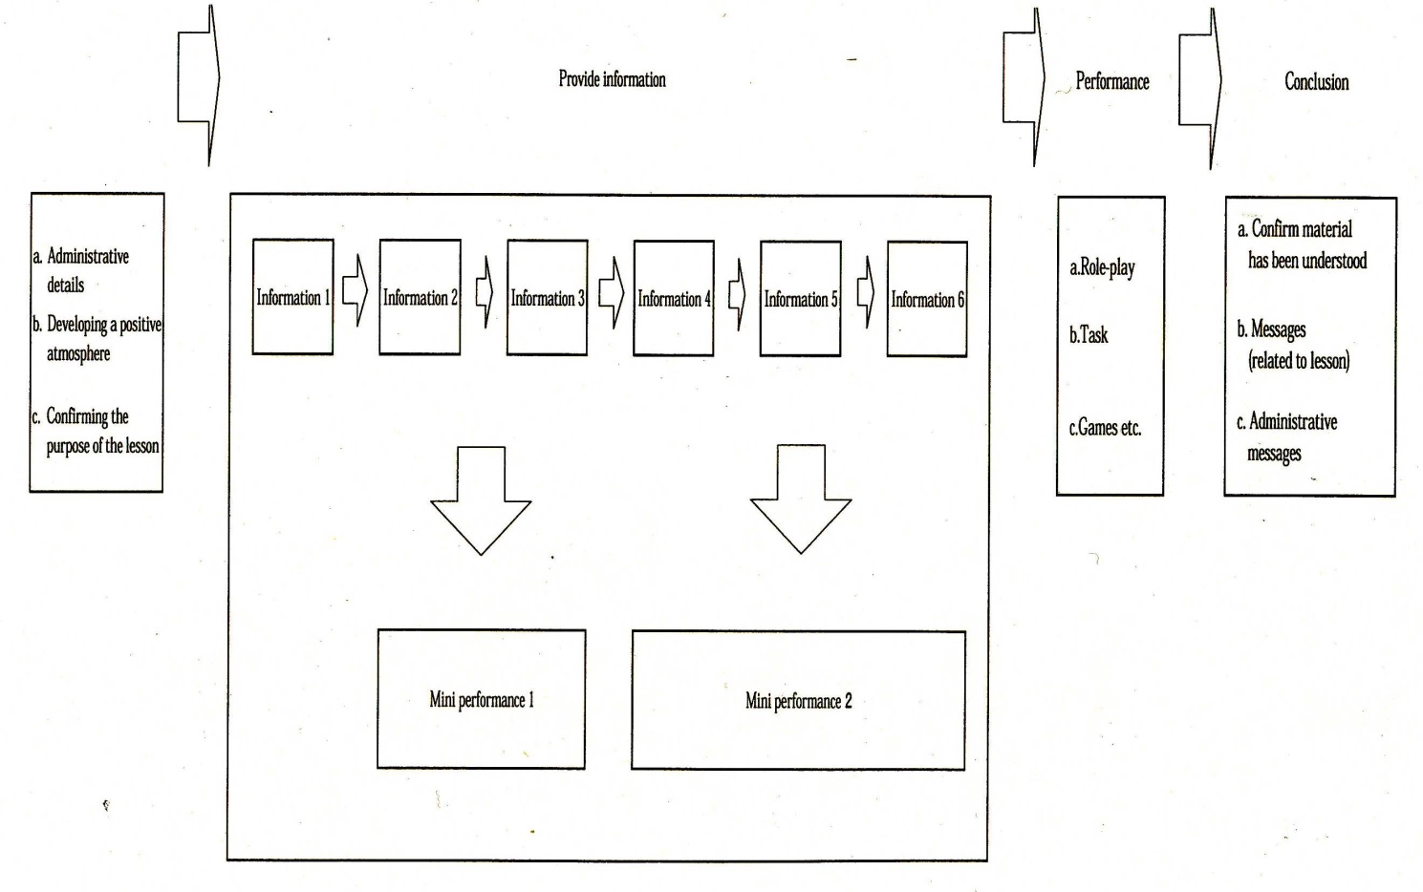
Source: Maruyama, Keisuke (2005). JET shonen no tame ni nihongo no
oshiekata (Teaching Japanese for JET participants). JET Programme Japanese
Language Course - Linguistics and Pedagogy Course: CLAIR.

Reading / Writing Classes

The last way to conceptualize lesson flow is unique to reading and writing classes. If you are teaching reading or writing, even for one lesson in your overall syllabus, the aforementioned ideas still apply. But the format looks a bit different. Your information will be skills or strategies for reading or writing, but your activities will be very structured differently. In TEFL, they are called Pre-While-Post activities (PWP). Basically, you have activities to prepare the students for reading or writing, activities to do while the students are reading or writing, and activities at the end to process what they read or wrote.

Pre-activities often include group discussions and front-loading students with information relevant to the material. Questions to ask yourself while planning such a discussion include: What are the themes? What do the students already know? What should they know about the style? What should they be preparing to practice? How can I prepare my students to understand? Do I need to provide vocabulary lists? Should they research words themselves ahead of time? Can they predict?

While-activities keep students on track and focused on the main objective, and include things such as highlighting while reading and using the writing process. Questions to ask yourself include: How can they implement and use their strategies? Will this involve notes, charts, and activities? Do they need to look up words now or later? Should they circle or underline new or familiar forms? Will they need paper?

Post-activities include sharing information in groups, comparing pictures, retelling, etc. Will they make a poster? Do a play? Fill out a form? Have a discussion? What language do the students need to learn to discuss the text?

“Real life” activities are just as important here as is in communication lessons. If your students are reading for pleasure, a test at the end is inappropriate, but a discussion on the plot and characters would be very germane. If your students are reading a menu, they probably don’t need to understand everything on it. In this case, questions such as “You have $10. Can you afford to eat here?” and “What will you order?” would be appropriate. This applies to while-activities, too. Reading out loud, for example, is highly complex process that is unhelpful for all but advanced students. If there is an error, you won’t know if it is due to misinterpreting pronunciation, misunderstanding a word, or misunderstanding an entire concept. Furthermore, unless they are in a teaching situation, most people do not read loud in real life. A better and more realistic method would be to have your students read a passage many times, consider the content, and then look up and summarize without looking back at the text.

HOW TO PLAN A LESSON

Now that we know the general flow of a lesson, let’s look at how to plan one. When you are first learning how to teach, it is very easy to fall into the trap of planning a worksheet or a game before thinking about what to teach your students. Unfortunately, this ultimately wastes time as you go back to revise details as the plan develops. Even worse is when you make a worksheet but later realize that the content doesn’t match what you were supposed to teach. Thus, it is vital to create your lessons by starting with the big picture and working down to the details. The best way to do this is to start with an overarching objective for a group of lessons, then plan individual lessons to fit that objective, and then plan the details of those lessons. Ideally your lessons will fit into the grand scheme of the curriculum, as determined by the textbook, the guidelines set down by the Ministry of Education, your schools, and your particular goals. To accomplish that, feel free to ask your JTE about their desires for the class, too. However, as many JETs won’t be able to plan multiple sequential lessons, we’ll look at the process for creating a single lesson. That process is:

1. Set a specific objective
2. Decide on the information to present
3. Plan the lesson flow
4. Fill in the details
5. Make the materials

Setting Objectives

Before you do anything else in a lesson – make a handout, plan an activity, or consider grammar points – set a lesson objective. Not only will this save you time re-doing worksheets and plans, it will make your lessons concise and orderly. You can even write your objective on the board each day so that your students will know what the purpose of your lesson is. Specifically, the objective is what you want your students to know or be able to do by the end of class. This is as measurable question to ask yourself, whereas “What will my students do today?” is not.

As with personal goals, lesson objectives need to be explicit, measurable, achievable, and relevant to the needs of the student. “Students can live in the US,” “Students can live in Chicago,” “Students can get around Chicago,” and “Students can use the CTA (Chicago public transportation),” are all too broad. “Students can purchase a CTA pass at a convenience store using ‘I’d like to buy a one-month pass,’ ‘How much is it’ and ‘Can I pay with a credit card;’ is a much better place to start. Or, if you are looking at a cultural lesson, rather than “Students will appreciate British history,” try “Students will learn four things about the holiday Burns Night.”

Deciding on Information

Once you have your objective, consider what items you need to teach to achieve that goal. If your lesson revolves around shopping, your teachable material could include times, numbers, prices, this/that, place names, greetings, intention, and various nouns and verbs. Only some of those will be coverable in a single period, though. If you are using a textbook, you’ll need to be familiar not only with the chapter you are teaching, but also all prior chapters to know what the students have already covered. You’ll also need to check if the textbook grammar and vocabulary are those that you want to use in your lesson. Even if your text is very well organized, there will likely be some phrases that your students will need that aren’t included in the chapter.

Planning the Lesson Flow

Once you’ve decided on what to teach, it’s time write out the flow of the lesson from introduction to conclusion. This is where all that work of deciding what order to teach things comes into play.

Filling in the Details

Now you can finally ask yourself, “How do I want to teach this information?” It is important at this phase to include practical exercises, and to keep in mind the different ways in which students learn. Will you use cloze (fill-in-the-blank) activities, dialogues, writing practice, games, drawing? If you’re giving homework, will it be writing, practicing, listening to a tape, or memorizing a dialogue? To ensure high interest, ask yourself, “Are these activities interesting to me / can I do these?” Also remember that the shortest path to your goal is the best – you don’t have to include all of the fanciest methods or activities to get the information across. And don’t forget to include some sort of assessment to see that your objective was met. This assessment doesn’t necessarily have to be a quiz, homework, or a poster. It could be as simple as a question asked to each student on the way out of class.

When you write your plan, include things you’ll need to know during the lesson. Don’t wait until mid-class to think of example sentences or probing questions. And don’t worry about looking at your notes. You’ll still look more prepared than if you were fumbling for ideas. As you grow as a teacher, you will find many activities and management methods that work particularly well. Trial and error, reading books on teaching methods, watching other teacher’s lessons, and recording your own for later review will all give you insight into which methods work the best. In addition, be sure to reflect on your lessons once you are finished. Try to make a few notes in a journal or on your plan about what you could modify or change to improve next time, what factors could have contributed to success or failure, or what went particularly well. Don’t simply walk away from a lesson, whether it was good or bad. You’ll thank yourself later.

Make your Materials

Finally, you can make the materials for class. Flashcards, worksheets, pictures, signs, and especially realia are all great ways to boost interest and save valuable class time instead of writing everything on the board. Your students will notice the effort you put into your materials, so try to give yourself enough time to do them the courtesy of giving your best. If you do find yourself without enough time to make materials, at least give some forethought to what you will write on the board, and how you will arrange it for clarity.

FREE ADVICE

Finally, a few tricks I’ve learned about lesson planning along the way:

As JETs, most of us will work directly with our JTE colleagues. If team-teaching is the model your school promotes, be sure to collaborate with them during the planning process, as well as in the classroom. JTEs have a distinct advantage over most non-natives in understanding Japanese students, their learning methods and abilities, and English acquisition. In the classroom, this sort of collaboration manifests with open and respectful communication in English as the lesson progresses. Not only will this create a more harmonious workplace which your students will pick up on, but it will present the JTE as a confident and competent Japanese speaker of English – a role model that is sometimes missing in the classroom narrative, and one that your students will benefit from having.

Don’t be afraid to write long lessons. A lesson on numbers could be a page and take one class, while a lesson on conditionals could take four or five and run a week or more. You can stop anywhere and continue on the next time, and having extra activities will make you calmer and feel less inclined to draw out the activities beyond their enjoyable length. Furthermore, don’t worry if you don’t finish your lesson. You can always pick up where you left off later, and rushing will only lead to confusion and inadequate practice.

There is no perfect format, so find that works best for you by looking at many different lesson plans. I find a grid system that includes what I’m teaching, what I’ll tell the students, and what materials I need for each section to be very helpful. Although when I’m first planning a lesson, I often write it out in outline format. Also, section times will help keep you on task, and a cover page with the lesson objective, classroom setup notes, a list of the information to be taught, and special teacher instructions will help you review at a glance.

Plan what your students will be doing while you are teaching. Will they be writing? Listening?

Post your lesson objective in the classroom every day. It will help keep your students on track, you on track, and if you should happen to be randomly observed that day, your visitors will know what you are trying to achieve, too.

If you can, try new lessons on your best classes first. If it doesn’t work after three tries and revisions, then consider more drastic changes or scrapping it.

Don’t forget to review and quiz students on past information frequently. Research shows that because the act of retrieving information from memory works like a muscle that gets stronger with use, frequent quizzes work better at moving information to long-term memory than frequent study. Also, don’t be afraid to plan a review lesson for techniques you have taught after a few successive classes, particularly before a mid-term or final exam. Students need repetition and review. By helping them by understanding their limitations, they will come to understand that you truly aim to support them.

Good luck!

